***Interplay of Bioinformatics and System Biology Techniques for Discovering Dendritic Cell-Specific Novel Biomarkers for Diagnosis and Treatment of Alcohol Use Disorder***

**Abstract:**

***A***lcohol use disorder (AUD) is a widespread behavioral health issue that affects millions of people worldwide and has a substantial influence on morbidity and death. It is critical to identify and treat Alcohol Use Disorder (AUD) as soon as possible to minimize harmful health effects. We still don't fully comprehend the complex biochemical foundations and relationships underlying AUD, despite tremendous progress in this area. In order to find Dendritic Cell-specific biomarkers, decipher gene ontology, outline pathways, clarify regulatory interaction networks, and investigate protein-chemical compounds connected to the molecular mechanisms of AUD, this study uses single-cell RNA sequencing in conjunction with bioinformatics analysis and network-based physiological approaches.When the gene expression profile data sets for GSE182173 and GSE182440 were analyzed to find molecular markers in AUD, 82 mutually differentially expressed genes (DEGs) were found. The hub genes that scored best on the PPI network were found to be possible novel biomarkers for the diagnosis of alcohol use disorder. These DEGs were then used to build a PPI network. Then, a large number of TFs, including GREB1, SRF, FOXC1, GATA2, PRDM1, and YY1, and miRNAs, among them are hsa-mir-23b-3p, hsa-mir-129-2-3p, hsa-mir-23a-3p, hsa-mir-34a-5p, and hsa-mir-21-3p. were discovered to be among the common genes associated with alcohol use disorder. We also used gene set enrichment analysis (GSEA) to identify important gene ontology concepts connected to DEGs in AUD. Based on illness connections, a number of possible chemicals, such as arsenic trioxide, valproic acid, tetrachlorodibenzodioxin, and retinoin, have been predicted to be correlated with alcohol consumption disorder (AUD). In order to improve knowledge of the molecular causes of AUD, enable early diagnosis, and direct the creation of successful treatment plans, this research attempts to uncover molecular markers at both the RNA and protein levels.

**1.Introduction**

Alcohol use disorder (AUD) is a persistent and recurring problem that impacts a large number of individuals globally and leads to substantial illness and death [1]. AUD is characterized by obsessive alcohol use, lack of control over intake, and unpleasant emotional states during abstinence [2]. The pathogenesis of AUD is complicated and includes various brain areas, neurotransmitter systems, and molecular pathways[2]. However, the underlying processes of AUD are still not completely understood, and there is a lack of useful biomarkers for diagnosis and treatment of AUD [3]. An essential function of dendritic cells (DCs), which deliver antigens, is to development and control of immunological responses that are adaptive [4]DCs are also involved in the control of neuroinflammation and neurodegeneration, which are implicated in the development and progression of AUD[1]. Recent studies have demonstrated that alcohol consumption changes the phenotypic and function of DCs in numerous organs, such as the liver, spleen, and brain [5]. Moreover, DCs may interact with other immune cells, such as T cells and microglia, and impact their activation and polarization [6]. Thus, dendritic cells (DCs) might be viable candidates for the identification and management AUD, or alcohol use disorder. Millions of people worldwide are impacted by Alcohol Use Disorder (AUD), a widespread global health concern. Finding cutting-edge diagnostic techniques and efficient treatment plans is a pressing need. In this study, we investigate how systems biology and bioinformatics might work together to discover new biomarkers for AUD that are unique to dendritic cells. The incidence of AUD is a serious issue, and comprehension of its effects is essential [7]. Finding biomarkers to support diagnosis and therapy is necessary due to the complex nature of AUD. Through the use of systems biology and bioinformatics techniques, we are able to identify certain biomarkers linked to dendritic cells, which might provide important insights into the pathophysiology of AUD [8]. The goal of this study is to address the urgent need for efficient treatments in this worldwide health concern by aiding in the creation of novel diagnostic tools and focused treatment plans for AUD[9]. Millions of Americans suffer from alcohol use disorder (AUD), which has a catastrophic effect on people's lives, families, and communities. It is estimated that over 29.5 million individuals in the US suffer with AUD[7].A number of negative health consequences and life-impairing characteristics are with relation to alcohol consumption disorder (AUD), including excessive drinking and obsession with alcohol [10][11]. In order to treat the physical, psychological, and social ramifications linked to this chronic disease, specific therapies are needed [12]. Smoking and male gender have been shown to be important factors of AUD [9], indicating that the burden of AUD is not only in the US but also in East Asian nations with high prevalence rates. In order to solve this public health issue, there is an immediate need for efficient prevention, treatment, and support services due to the severity of AUD and its effects on both people and society together. Long-term alcohol use has been shown to cause immunological dysregulation by upsetting immune homeostasis and compromising pathogen identification. This process involves the complicated involvement of Dendritic cells (DCs) are vital constituents of the immune system [13]. Heart problems and liver ailments are only two of the many health issues that been associated with alcohol consumption disorder (AUD)[7]. In addition, those who have AUD are more prone to experience adverse consequences from a SARS-CoV-2 infection, including death, intensive care, and hospitalization [14]. It has been shown that medication therapies for alcohol-related liver disease (AUD) not only enhance results related to drug use, but also lower the occurrence and postpone the advancement of ALD [15]. Research into the molecular processes underlying the development of AUD and its genetic base is still underway, with a particular emphasis on the intricate interactions between environmental and genetic variables as well as epigenetic modifications [16]. As key players in the immune system, dendritic cells (DCs) coordinate immunological responses and perform the role of link between immunity that is innate or adaptive. Long-term alcohol use may interfere with DC function, reducing immune system protection and ability to recognize pathogens. Comprehending the molecular changes in DCs resulting from alcohol exposure is crucial in comprehending the pathophysiology of alcohol use disorder (AUD). As possible therapeutic targets and indicators for the course of illness, DCs exhibit certain surface markers and release cytokines. DC targeting may influence immune responses and enhance therapeutic results. Consequently, the goal of our study is to find new DC-specific indicators that can direct customized treatment approaches [17], [18] [19], [20] . Pre-dendritic cells, or pre-DC, are on the rise, and Nagafuchi et al.[21] found this to be a possible biomarker for treatment resistance in rheumatoid arthritis (RA) by doing extensive transcriptome analysis Several subgroups of immune cells in peripheral blood. The most significant correlation with treatment resistance was discovered in the nuclear expression module of dendritic cells with plasmacytoid function (pDC), which represents the growth of pre-DC. Before therapy, treatment-resistant individuals had a noticeably larger percentage of pre-DC. Furthermore, integrating the variability of DC populations and cell-cell interactions, Aghamiri et al. [22] created a rational and predictive model of dendritic cell (DC) activity. By allowing for in-silico studies on human DCs for vaccine development, medication discovery, and immunotherapies, this model may be utilized to investigate cell dynamics and disease settings. Together with the development of focused therapeutics and diagnostic tools for an assortment of disorders, notably alcohol use disorder (AUD), these discoveries and computational models may aid in the discovery of new biomarkers unique to DCs.The objective of this work is to uncover molecular biomarkers that indicate the correlations between associative variables and the progression of AUD. The main objective of this research is to use genomic data in order to identify shared genes and genes that exhibit differential expression that have been associated with alcohol consumption disorder (AUD). Our objective was to develop molecular biomarkers for the early assessment of alcohol consumption disorder (AUD) and its progression by analyzing transcriptional and post-transcriptional levels. Simultaneously, we aimed to discover significant gene list components that may work synergistically to provide valuable medications or targets for further investigation**2.Methods**

A graphical representation of the interplay between bioinformatics and systems biology techniques to discover novel dendritic cell-specific biomarkers for the diagnosis and treatment of Alcohol Use Disorder (AUD) is presented.

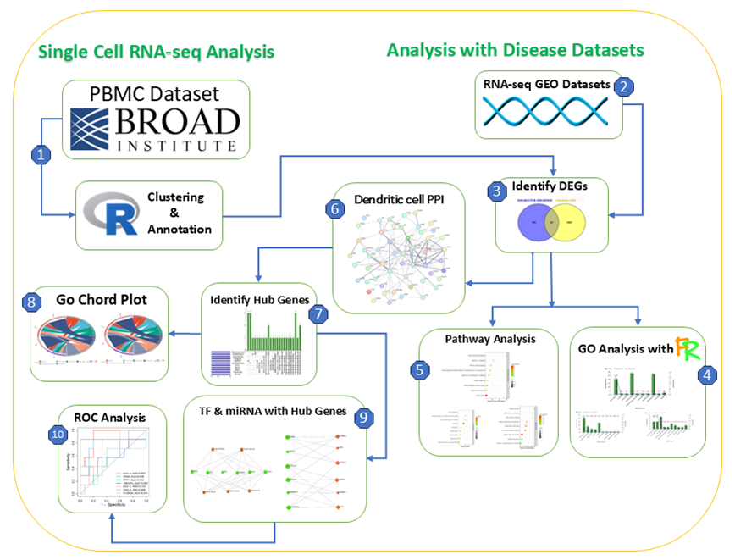

**Figure 1:Graphical illustration of the workflow for discovering dendritic cell-specific biomarkers in AUD using bioinformatics and systems biology techniques.**

**2.1 scRNA-seq data acquisition along with processing**

The publicly accessible scRNA-seq data PMID: 28212749, data taken derived from a patient's peripheral blood were retrieved from the Single Cell Portal [28]. Data processing was carried out using R V4.3.1 and the Seurat package V4.3.0[23]. Following filtering, the data is normalized using the "LogNormalize" approach, which involves multiplying each cell's feature expression measurement by the overall expression, scaling the measurements by a scale factor, and then log-transforming the resulting data. For PCA and other downstream analysis, Seurat's Find VariableFeatures() function finds 2,000 highly variable features. The data is first scaled and superfluous sources of variation are removed using the ScaleData() method, which improves the precision of the analyses that follow dimensional reduction.[24]. Seurat v3, which builds upon the Louvain methodology, clusters data using a graph-based method. Cells are added to a network structure using KNNs, where edges link cells with comparable feature expression, to identify cell clusters using K-means clustering. The procedure divides the network into closely knit communities by using modularity optimization techniques, including the Louvain algorithm. [25]. First, data is transferred from Seurat to the format of SingleR. This is because reference-based cluster annotation is not included in the Seurat package. The R package Monaco is used for reference-based annotation, which enables direct comparison with well-chosen reference sets. [24].

**2.2 RNA-seq gathering information.**

The RNA-seq datasets GSE182173 and GSE182440 gene expression profiles are sourced from the GEO (Gene Expression Omnibus) database maintained by the National Center for Biotechnology Information (NCBI) associated with AUD. This public repository provides free access to high-volume functional genome data, including data from next-generation sequencing and microarray analysis.[26]. The blood lymphocytes are the source of the sample cells. For both GSE182173 and GSE182440, we have a total of 24 samples 12 are control and 12 are case for an alcohol use problem. Following dataset analysis, Significant DEGs have been identified and extracted.

**2.2. 1 Sorting genes with diverse expression patterns (DEGs)**

GREIN {http://www.ilincs.org/apps/grein/} is a web-based application for RNA-seq data exploration that was used to examine DEGs. The DEGs were deemed significant as they were found within the cutoff range (P <.05 and logFC >= 1, logFC ⩽ −1). To change the P-value in this study, the Benjamini–Hochberg (BH) approach was used. Utilizing Venny 2.0.1, an online VENN analysis tool (bioinfogp.cnb.csic.es/tools/venny/),[27]. With the use of this program, we have retrieved the matched genes between scRNA-seq data sets DEGs of our RNA-seq dataset for further study.

**2.3 Matching datasets from RNA-seq and scRNA-seq**

For AUD (Alcohol use disorder), our targeted immune cells (Dendritic cells) form scRNA-seq, and DEGs of RNA-seq data sets were crossmatched in this portion of the study. In this case, the targeted cells for AUD are the Dendritic cells. Given that those cells' genes are closely related to AUD (Alcohol use disorder) [28] [29].

**2.4 Pathway investigation and functional enrichment of DEGs**

We made use of the standalone program funrich (version 3.4.1)[30] for pathway analysis and gene ontology (GO) functional enrichment of DEGs. An internet-based bioinformatics tool for integrated discovery databases, annotations, and visualizations, or DAVID [31]The Kyoto Encyclopedia of Genes and Genomes (KEGG) route, Reactome pathway, BioCarta, and WikiPathways were all carried out using v6.8 [32]. To see the route figures, we utilized SRplot (https://www.bioinformatics.com.cn/en). The P-value < 0.05 criteria was taken into account in order to identify relevant functional and route keywords. pathways and GO were used to add a fantasy module for inference and to annotate the enrichment analysis of gene clusters and bio-term categorization procedures.

**2.5 DEGs' PPI network analysis**

Protein-protein interactions (PPIs) networks provide information on the molecular process behind cellular activity, which helps analyze pathogenic pathways and disease development. The Gene-Interacting Retrieval Search Tool (STRING v11.0) was used in this investigation[33] database for building the Dendritic cells PPI network of DEGs. Cytoscape (in 3.10.1 version) [34] was used to identify the PPI networks between the Dendritic cells DEGs. By taking into account the genes that are shared by at least seven of the eleven topological approaches (Radiality, Degree, BottleNeck, Betweeness, Stress, Closeness, EcCentricity, MCC, DMNC, MNC, EPC) in the Cytoscape plugin cytoHubba, we have discovered 11 KGs of Dendritic cells [35]. Additionally, we have created an upset storyline. [36] employing SR plot to view the genes that are employed in 11 techniques of cytoHubba. Finally, we crossmatched the 11KGs of Dendritic cells in venny2.0.1(VENN Tool) and found 7 hub genes of AUD (Alcohol use disorder).

**2.6. Chord diagram for the molecular route and the GO term**

The chord arrangement [37] shows a thorough connection between the enriched GO keywords or biochemical pathways of DEGs and their logFC. [http://www.bioinformatics.com.cn/en] SRplot)[38]a free online tool was used to create the chord plot[39] . The top seven GO words from each of the BP, CC, and MF ontologies were shown as a GO chord plot. Additionally, a total of nine routes—one from each of the KEGG, Reactome, Wikipathways, and BioCarta pathways—are included in the molecular pathway's chord diagram. Their DEGs are used to determine the logFCs. The chord plot for the seven GO keywords is then produced by entering them into the SRplot web server along their logFC and hub genes. Similarly, The molecular pathways' chord diagram is created by entering nine molecular routes into SRplot along using their logFC and hub genes.

**2.7 Regulatory biomolecule identification**

Significant regulatory macromolecules that significantly change transcription and expression consist of miRNAs and transcription factors (TFs). We used the Network Analyst v3.0 as a result. [40] web-based tool to predict interactions between TFs and DEGs and miRNAs using empirically verified Jasper [41] and databases using miRTarbase v8.0 [42] After that, we filtered the interaction networks to exclude nonmajor signature molecules using degree centrality and betweenness values of 2,6 for TF-protein interactions and 2,6 for miRNA-protein interactions, respectively.

**2.8 Analysis of protein-chemical compounds**

The substances in the chemical environment that generate comorbidities, or interactions between proteins may be found by analyses of protein–chemical compounds. Making use of the Comparative Toxicogenomics Database (CTD) and the HUB genes (common DEGs) [43], With Network Analyst's assistance, we were able to identify protein-chemical connections [40].

**2.9 Biomarkers validation via ROC curve analysis**

For the confirmation of important hub proteins and possible important transcription factors, we used the receiver operating characteristic (ROC) curve[82][83]. The appropriate cut-off, which influences the sensitivity and specificity of the test, is found using the ROC curve[84]. Bigger AUC values indicated better categorization [85]; the range of AUC values was 0.5 to 1.0. We gathered NCBI88 GEO profile files and visualized them using SRplot[81].

**3.Results**

**3.1 Processing SC RNA-Seq data to identify cell clusters and annotate**

After reading the raw dataset, we created a Seurat object so that it could be examined further. A Seurat object is a container that contains the matrix of UMI counts. The numbers in this matrix show how many molecules are found in each cell (column) for each attribute (gene, for example). We use initial quality control throughout the data read process to exclude poor quality cells with Not more than 200 expressed features (genes) and weakly expressed features seen within three cells or less. With Seurat, you can quickly examine QC data and apply any user-defined filter to specific cells. The community often uses the following QC metrics. The overall number of molecules inside a cell (strongly connected with unique genes) and the number of unique genes within each cell [44]

The significance of the structure that each principal component captures is estimated via the Jackstraw plot. To create the null distribution, which the p values are evaluated against, it randomly permutes a portion of the data (Jack straw figure). The traditional method used in computer science to analyze the cumulative variability in the data that is represented by the sum of the main components is the elbow plot. (Plot figure for elbow). The scaled data were subjected to principal component analysis (PCA) in order to decrease the dimensionality. The first ten main components two-dimensional data were shown using the t-distributed stochastic neighbor embedding (t-SNE).

Subsequently, we want to investigate characteristics (also known as markers or genes) that exhibit elevated expression inside each cluster relative to the other cells. We make use of "roc," which calculates each marker's categorization power. We have identified 28 clusters, and the heatmap displays the outcome. A clear visual depiction of groups sharing highly expressed markers is provided by the heatmap[24].

In this work, we have used reference-based annotation to determine the immune cells' annotation. Several immune cell types were studied using sorted cells. Reference-based annotation makes it easy to compare with well-chosen collections. However, the inference depends on the sets that are specified in the reference. Based on the Monaco reference, we identified five distinct kinds of cell annotations, as shown in ***Table 1***[45]

**Table 1:Cluster dispersal to annotation**

|  |  |  |
| --- | --- | --- |
| ***No of Clusters*** | ***No*** | ***Cell type*** |
| 3,5,11,18,23,25 | 6 | Natural killer Cell |
| 2,12,13,16,17 | 5 | B Cell |
| 0,1,4,6,8,9,10 | 7 | T cell |
| 7,14,15,19,20,26,27 | 7 | Monocyte |
| 21,22,24 | 3 | Dendritic cells |
|  | Total=28 |  |

**3.1 Determine Which DEGs**

We used GREIN to investigate the tissue RNA-seq datasets GSE182172 and GSE182440 related to AUD (Alcohol use disorder). The cut off range (P <.05) and logFC ≥ 1, logFC ⩽ −1) are used to identify both downregulated and upregulated DEGs. It was discovered that 919 genes have varied expression patterns of these, 205 were upregulated and 310 were downregulated for GSE182173 while 258 were upregulated and 146 downregulated for GSE182440. Details of the dataset shown in Table 2

**Table 2:Study on RNA sequencing gathering results**

|  |  |  |  |  |  |  |  |
| --- | --- | --- | --- | --- | --- | --- | --- |
| ***Disease Name*** | ***GSE Number*** | ***Sample Size*** | ***Source of tissue/cell*** | ***Control Sample*** | ***Microarray or RNA seq*** | ***Dataset Link*** | ***Species*** |
| AUD | GSE182173 | 24 | Blood lymphocytes | 12 | RNA seq | [GREIN (ilincs.org)](http://www.ilincs.org/apps/grein/?gse=GSE46831)  [GREIN (ilincs.org)](http://www.ilincs.org/apps/grein/?gse=GSE46831) | **Homo sapiens** |
| GSE182440 |  | 12 |

We compared the genes from the RNA Sequence data set with the scRNA-seq datasets for Dendritic cells, we found 82 genes. Outcome of the cross-matched Genes are shown in ***Figure 1*** and ***Table 3***

**Table 3:Dendritic cell genes matched to scRNA-seq and RNA-seq datasets**

|  |
| --- |
| **Dendritic cell genes matched to scRNA-seq and RNA-seq datasets** |
| CNP,FAM107B,EVI2A,TGFBI,ELOVL1,SMIM5,S1PR5,PPP1R14A,MBP,HLA-A,SLC31A2,COL9A2,  RASSF2,HHIP,GREM1,CLDND1,MYO1E,TMC6,HLA-C,SNHG25,LITAF,HLA-F,ADGRG5,LILRA4,  RHOG,CXCL8,MCOLN2,DEPDC7,TYMP,LILRB4,FCGR3A,CEBPD,HMOX1,SLC1A5,CD3E,IFI30,  TNFAIP3,S1PR4,MYBL2,LILRB1,RNASE2,ZFP36,IER3,MYO1G,POM121L2,CCL4,GZMH,ARRDC3,TXNIP,NEUROD2,IFITM3,CD44,IL1R2,TIMP1,FGFBP2,RASD1,MTHFD2,MT2A,ARID5A,LILRB3  ,FBP1,BCL3,FPR1,SERPINA1,LENG8,DDAH2,OVOS2,ST14,IL4R,MYCBP,BCL2A1,GADD45B,LST1,GAPT,TRBC2,PDLIM1,FLT3,AIF1,HLA-DRB1,STX11,CSNK2B,S100A9, |
|  |

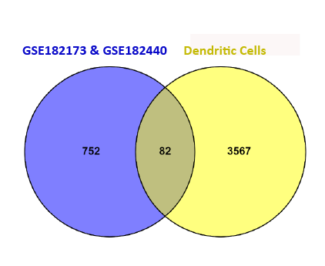

**Figure 2: Dendritic cell genes matched to scRNA-seq and RNA-seq datasets**

**3.2 Analysis of Functional Enrichment and Pathways**

In order to identify the routes with enhanced biological importance emphasized. We used gene ontology (GO) in this investigation and pathway enrichment analyses. Gene ontology utilizes gene functions and their constituents to provide extensive digital information. An ontology is a conceptual framework that defines and organizes a specific set of knowledge within a certain context. For the genes with differential expression, we perform functional and pathway enrichment analyses using Gene Ontology (GO). The Gene Ontology (GO) analysis was conducted using the FunRich program. DEG pathways are constructed using the DAVID tool, whereas plots are made using the SR plot tool. The most notable gene ontology (GO) enrichments for biological processes (BP), cellular components (CC), and molecular functions (MF) are shown in the picture as well as pathway enrichments in KEGG, Reactome, Wiki, and Biocharta for differentially expressed genes (DEGs) in Dendritic cells. P-values below 0.05 were considered significant for both Gene Ontology (GO) words and different pathways. In the Gene Ontology (GO) analysis, we have only taken into account the top 10 words based on their P-value.

**3.2.1 Dendritic cell GO result**

Let's have a look at the ***Figure 2*** in BP for the DEGs of Dendritic cells. The top 3 terms are based on the p value and the proportion of genes in the biological process categories of cell communication (28.2%), signal transduction (26.9%), and immune response (20.5%).

The p-value and the percentage of genes in the cellular component indicate in ***Figure 3*** of the plasma membrane (41%), exosomes (26.4%), and lysosomes (19.4%) in CC.

According to the p-value and percentage of genes for Molecular function in MF, Receptor activity accounts for 9%, Cytokine activity for 3.8%, and Motor activity for 2.6% in ***Figure 4*** .

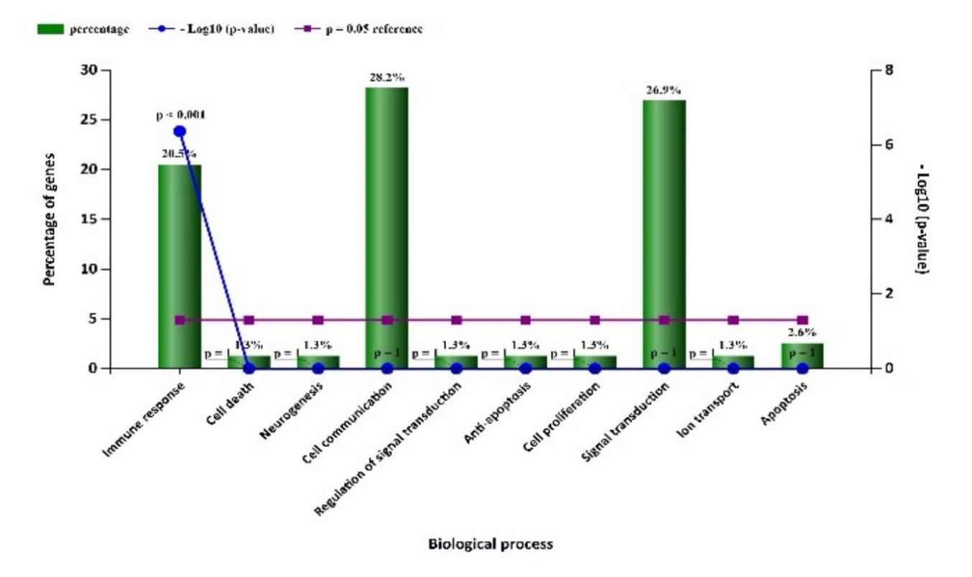

.

**Figure 3:Biological Process (BP)**

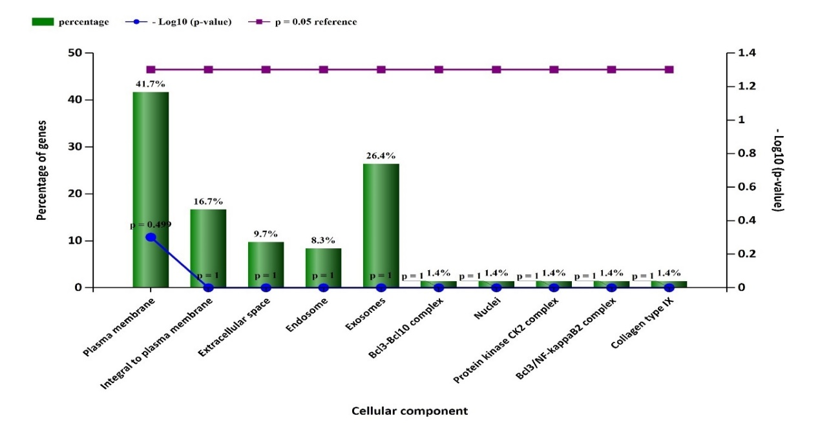

**Figure 4:Cellular Component (CC)**

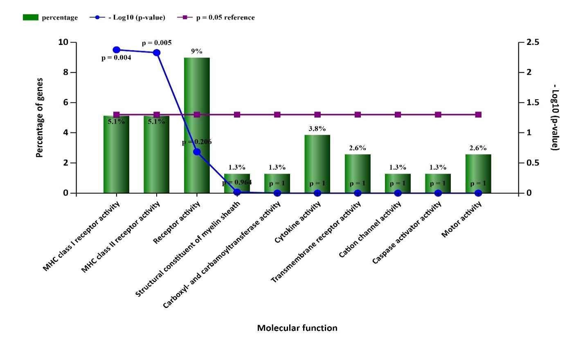

**Figure 5:Molecular Function (MF)**

**3.2.2 Pathway analysis outcome**

We have performed pathway enrichment analyses using KEGG, REACTOM, and WIKIPATHWAY. The study's top results were determined by taking p-values less than.05.

Regarding dendritic cells, the picture ***Figure 5*** of the KEGG pathway analysis illustrates the top-enriched pathways as the most enriched pathways for KEGG include antigen processing and presentation, autoimmune thyroid disease, Type I diabetes mellitus, graft-versus-host disease, and allograft rejection. ***Figure 6*** of the REACTOM pathway analysis for dendritic cells reveals that the most enriched pathways for REACTOM are the translocation of ZAP-70 to the immunological synapse, the NLRP3 inflammasome, the endosomal/vacuolar pathway, lysosphingolipid and LPA receptors, and the NLRP3 inflammasome.

Regarding dendritic cells, the top enriched pathways for WIKIPATHWAY analysis, as shown in ***Figure 7***, include lung fibrosis, TAR syndrome, nsp9-nsp10 complex-mediated pathogenesis of SARS CoV-2, and cancer immunotherapy via PD 1 inhibition.

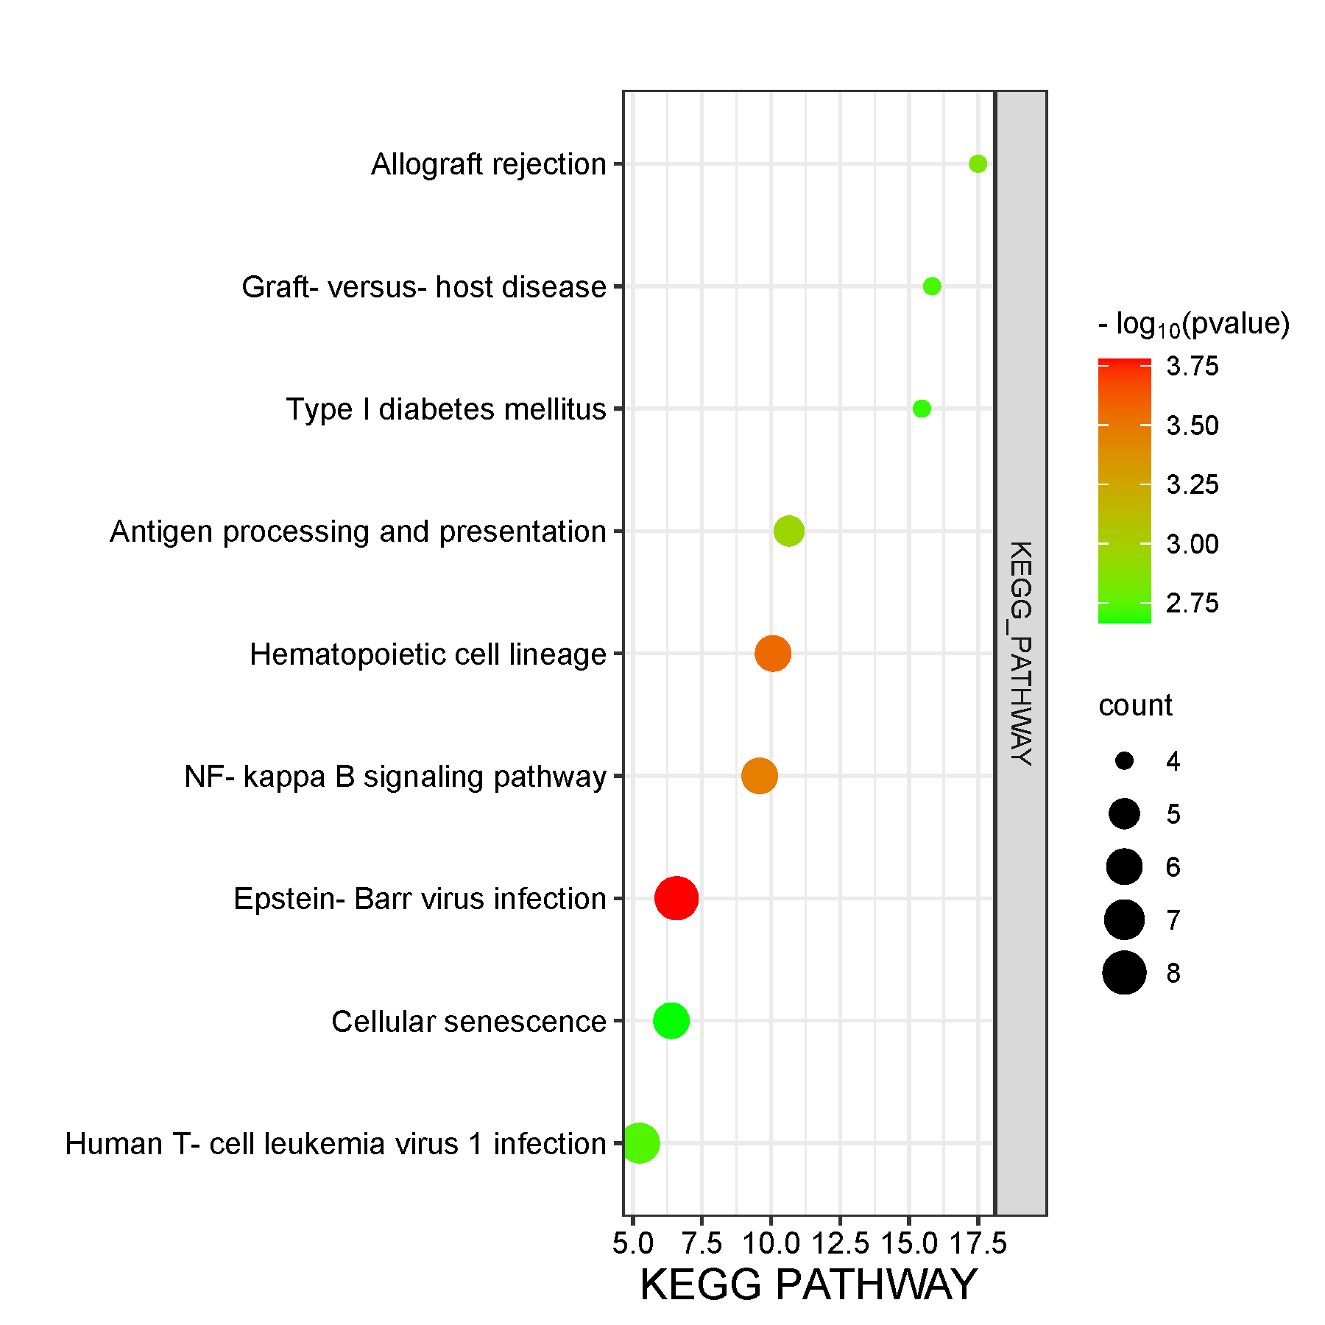

**Figure 6:KEGG Pathway**

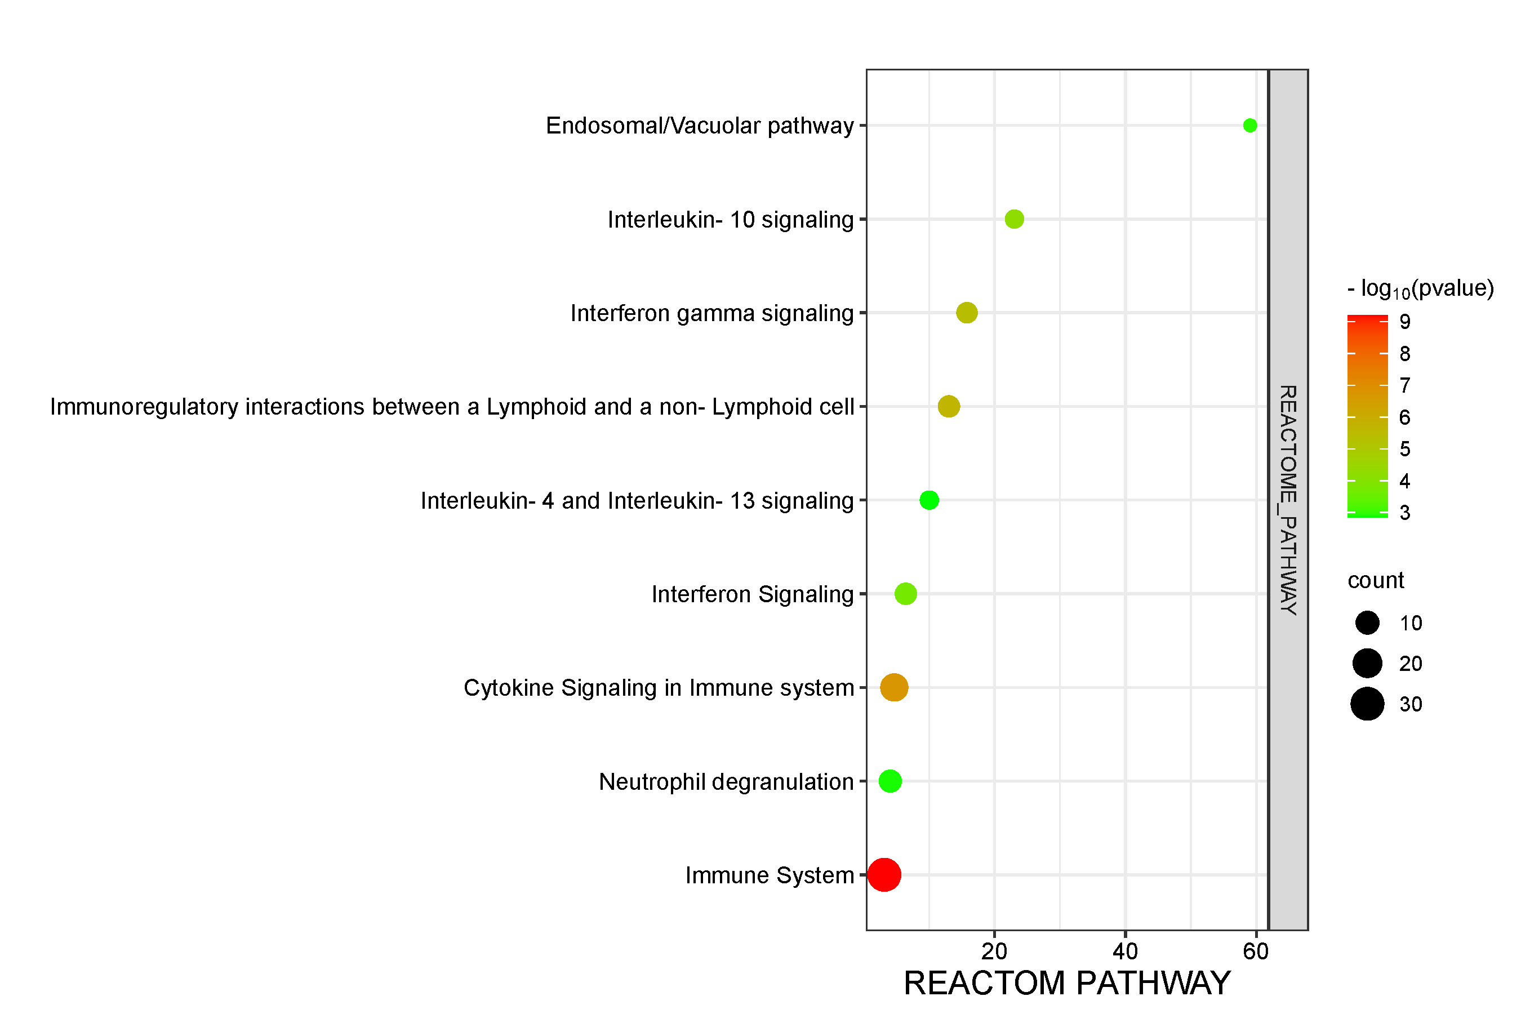

**Figure 7:REACTOM Pathway**

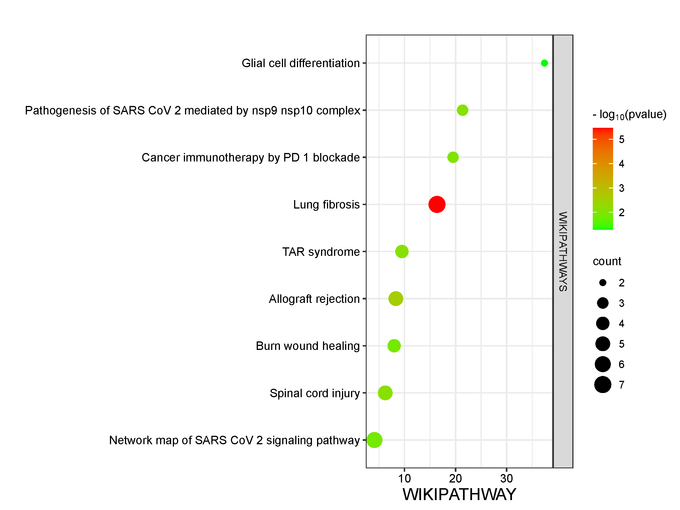

**Figure 8:WIKI Pathway**

**3.3 Identification of hub proteins and PPIs**

**3.3.1 KG identification and PPI creation for Dendritic cells**

A total of 82 DEGs of Dendritic cells were included in the PPI network shown in ***Figure 8***, including 140 edges and A PPI enrichment P-value of less than 1.0e-16 and an average node degree of 3.54 were found in 79 nodes. according to the online tool STRING.Eleven topological approaches (Betweeness, Stress, BottleNeck, EcCentricity, Radiality, EPC, MNC, Closeness, Degree, DMNC, MCC) were applied to the top 15 genes using The Cytoscape plugin called CytoHubba satisfied 11 algorithm in ***Figure 9***. Finding the hub genes we used these genes to build a UPSET plot in SRplot. We identified the genes in the Upset plot that span seven or more techniques. Consequently, we discovered seven genes that are regarded as KGs: CXCL8, FCGR3A,HLA-A, CD44,FPR1,TNFAIP3, and HLA-C.

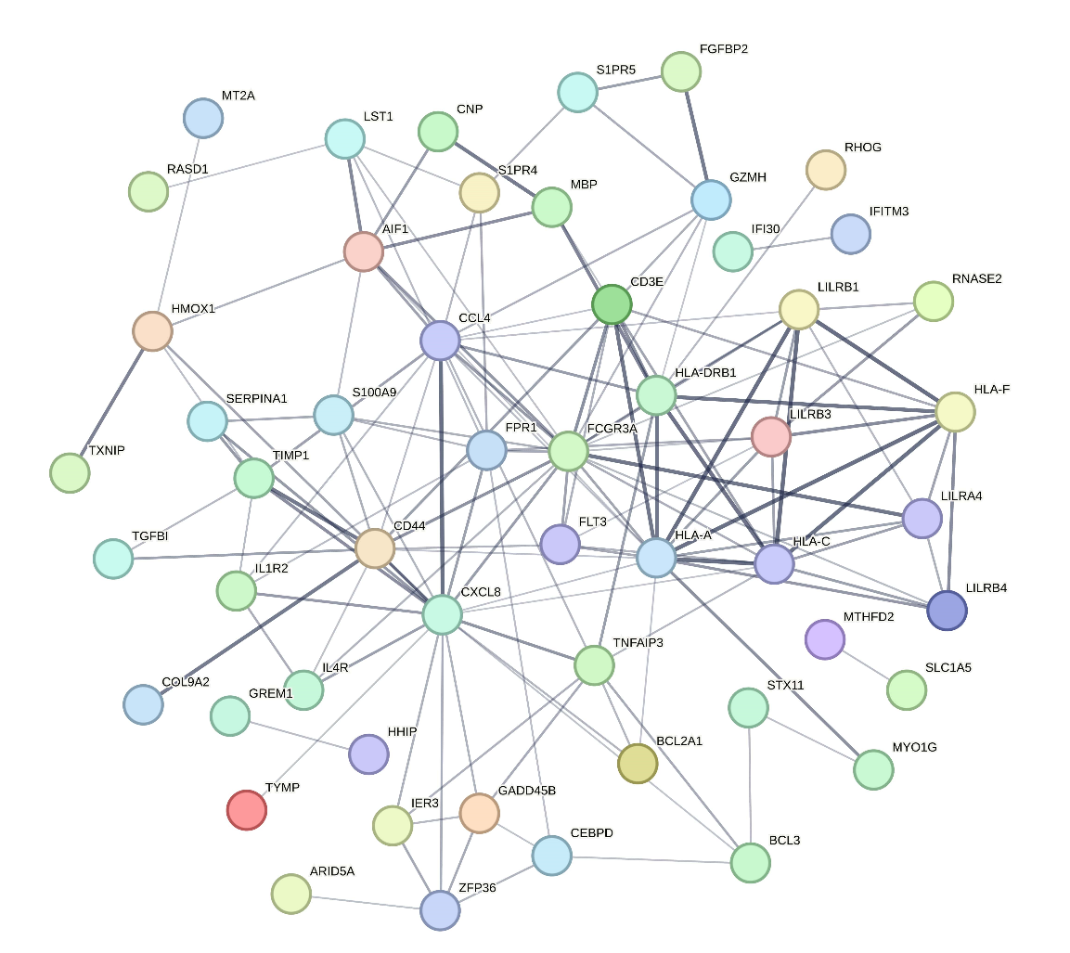

**Figure 9:Dendritic cell PPI, with the hub Genes**

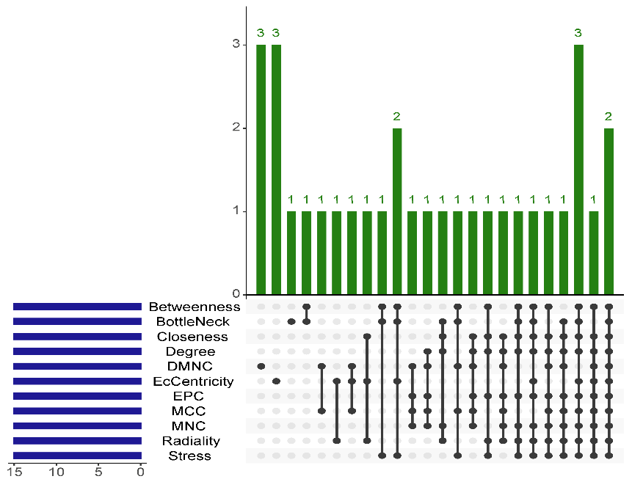

**Figure 10:Dendritic cell gene upset plot utilizing 11 cytohubba technique**

**3.3.3 Hub Gene Detection**

With the use of Venny 2.0.1, we compared the KGs of Dendritic cells in order to find the hub genes, and we were able to discover 7 hub genes. In the next phases, we also evaluated the relevance of the seven hub genes using other regulatory processes.

|  |  |  |  |  |
| --- | --- | --- | --- | --- |
| ***Gene symbol*** | ***Gene Function*** | ***Description*** | ***Uniport ID*** | ***Reference*** |
| CXCL8 | C-X-C motif chemokine ligand 8 | In a section of chromosome 4q, this gene forms a gene cluster with other members of the CXC chemokine gene family. | P10145 | [46] |
| FCGR3A | Fc gamma receptor IIIa | There is an adjacent gene (FCGR3B) on chromosome 1 that is quite similar to this gene (FCGR3A). | P08637 | [47] |
| HLA-A | major histocompatibility complex, class I, A | This gene is engaged in immune response or antiviral activity and has been studied for its role in coronavirus biology. | P04439 | [48] |
| CD44 | CD44 molecule (IN blood group) | Numerous biological processes, such as lymphocyte activation, hematopoiesis, recirculation and homing, and tumor spreading, are facilitated by this protein. | P16070 | [49] |
| FPR1 | formyl peptide receptor 1 | A member of the G-protein coupled receptor 1 family, this gene encodes a G protein-coupled receptor found in mammalian phagocytic cells. | P21462 | [50] |
| TNFAIP3 | TNF alpha induced protein 3 | Tumor necrosis factor (TNF) has been shown to quickly stimulate the expression of this gene. | P21580 | [51] |
| HLA-C | major histocompatibility complex, class I, C | This gene is engaged in immunological response or antiviral activity, and its role in coronavirus biology has been examined*.* | P10321 | [52] |

**3.4 Chord diagram displaying important biological pathway and gene ontology**

**GO Chord table**

|  |  |  |  |  |
| --- | --- | --- | --- | --- |
| **Pathway name** | **ID** | **PValue** | **HUB Genes** |  |
| Immune response | GO:0006955 | 2.44266E-09 | CXCL8,FCGR3A,HLA-A,HLA-C | |
| Exosomes | GO:0070062 | 0.00408589 | HLA-A,CD44,TNFAIP3,HLA-C | |
| Plasma membrane | GO:0005886 | 0.000636718 | FCGR3A,HLA-A,CD44,FPR1,HLA-C | |
| Receptor activity | GO:0004872 | 0.000921633 | FCGR3A,CD44 | |
| MHC class I receptor activity | GO:0042288 | 1.8815E-05 | HLA-A,HLA-C | |
| MHC class II receptor activity | GO:0032395 | 2.096E-05 | HLA-A,HLA-C | |

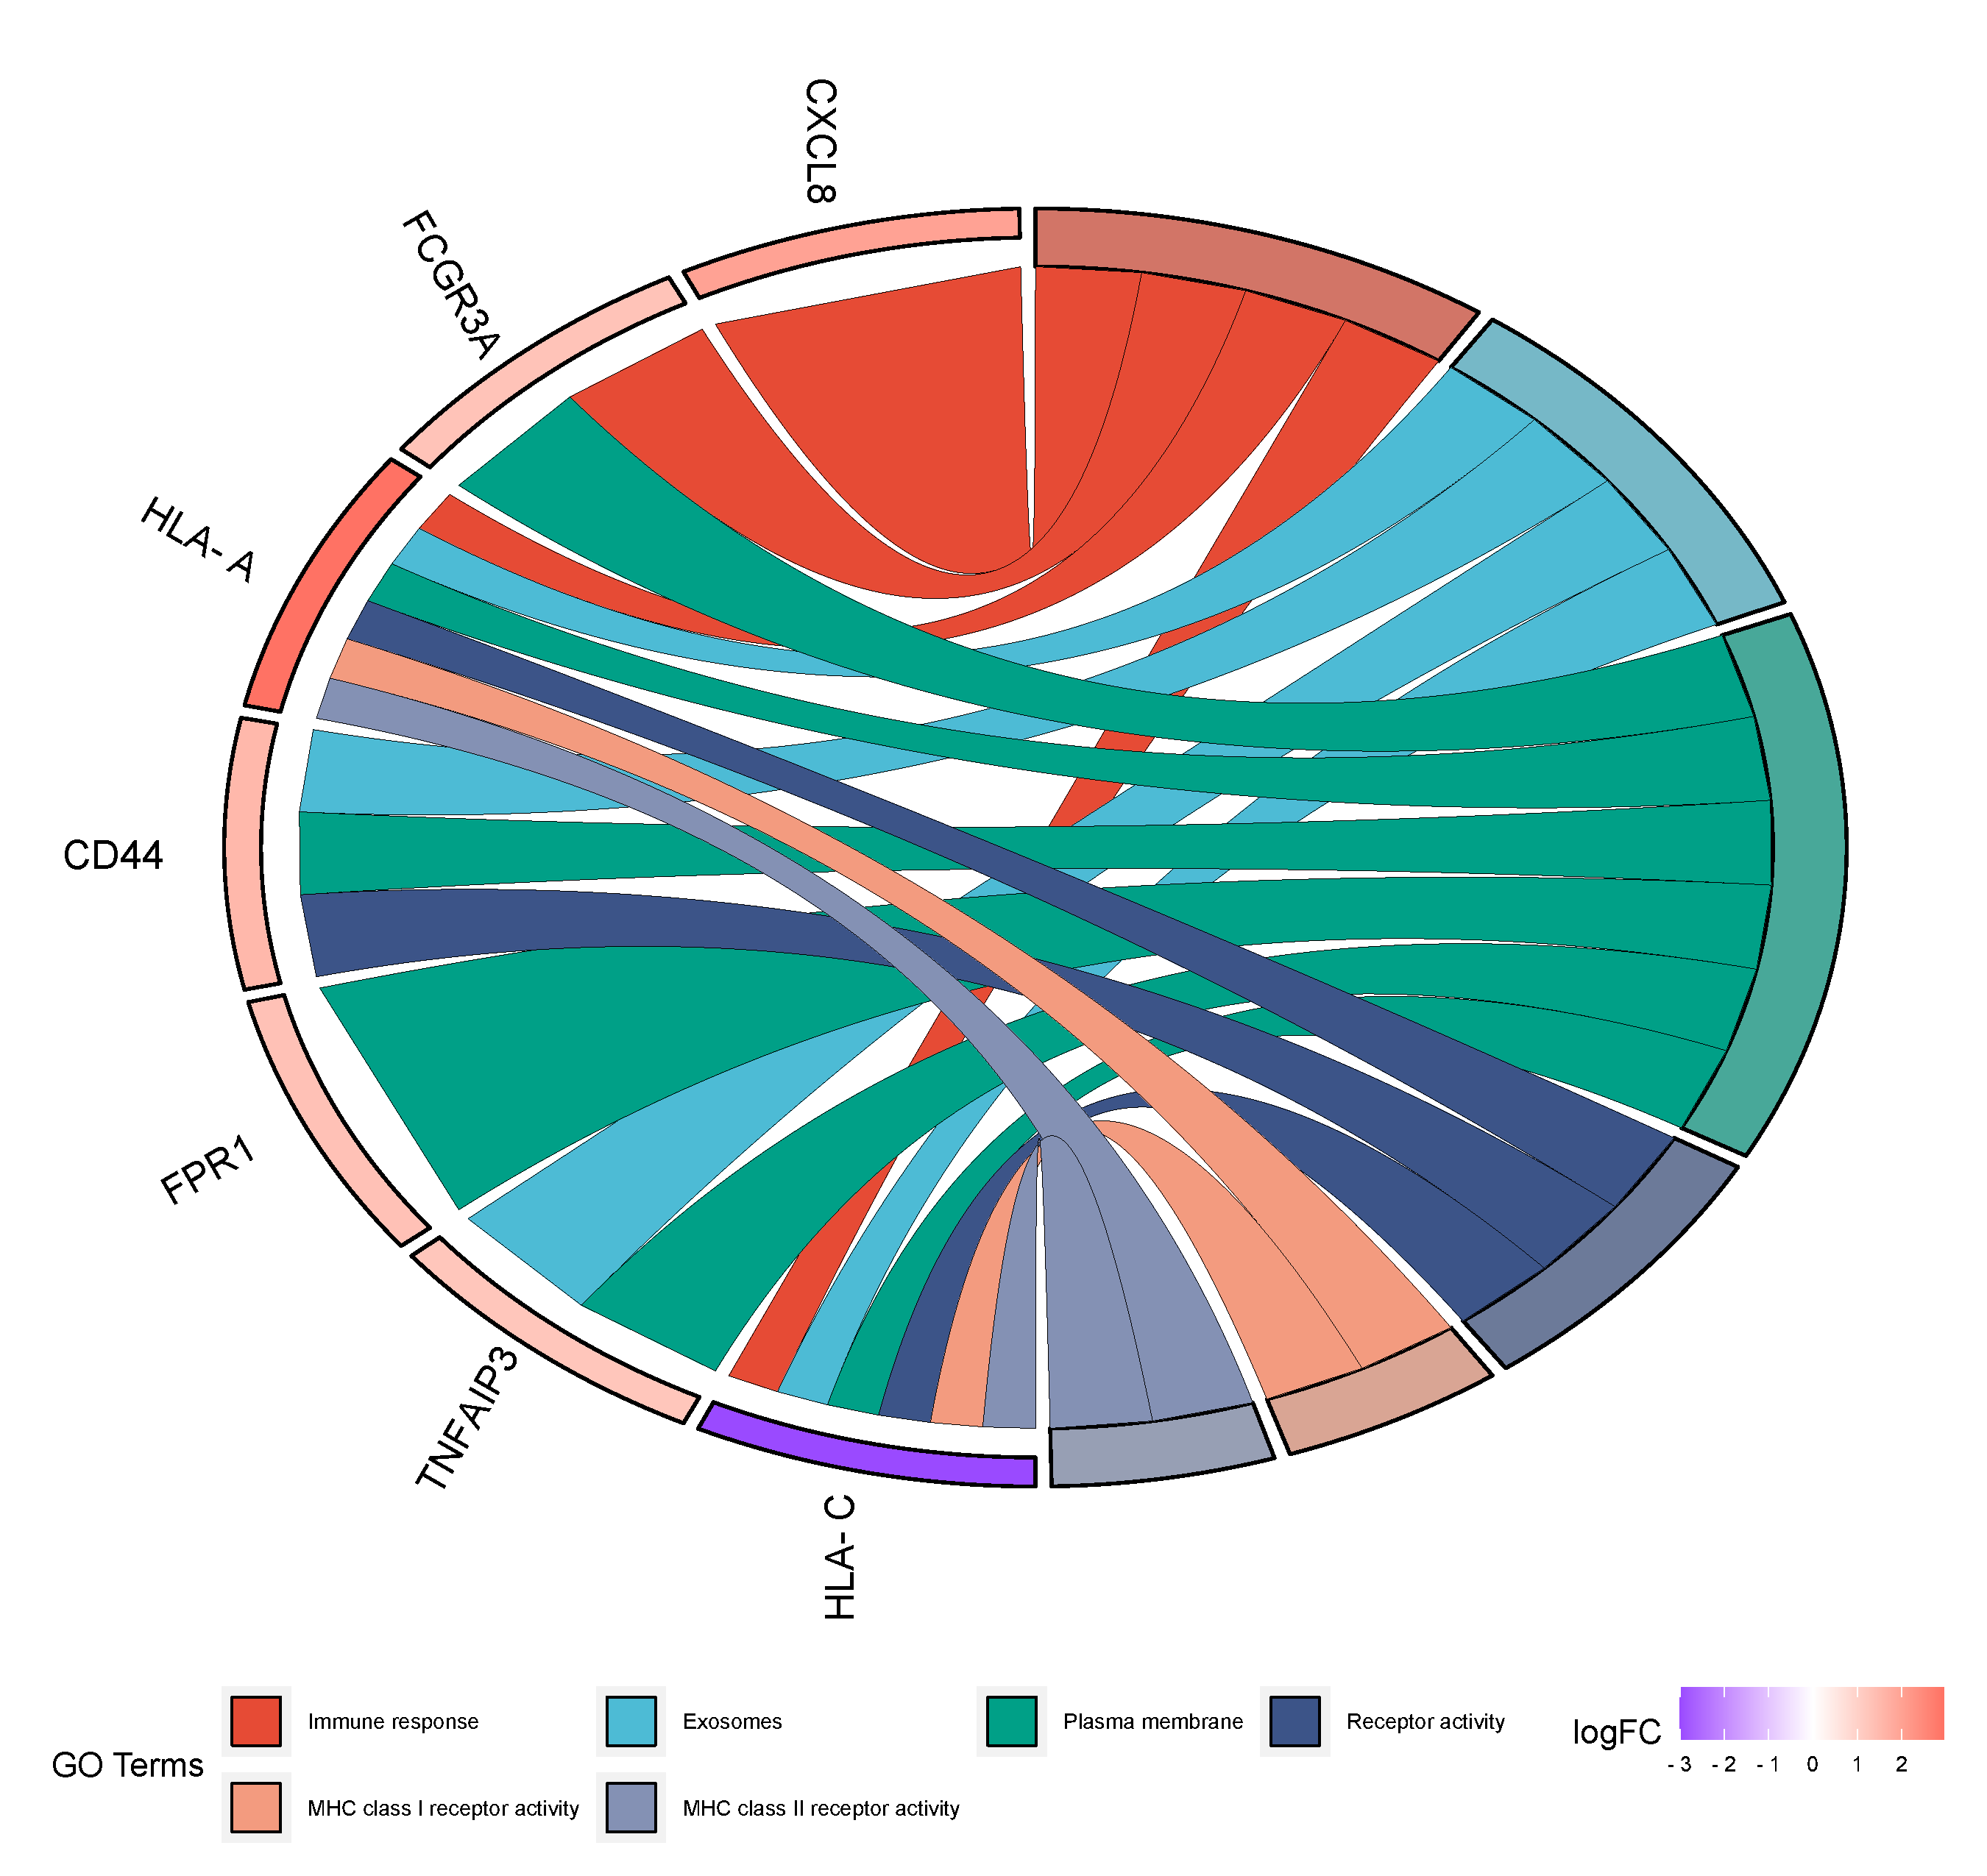

**Figure 11:GO Chord Diagram**

**Pathway Chord table**

|  |  |  |  |  |
| --- | --- | --- | --- | --- |
| **Pathway name** | **ID** | **PValue** | **HUB Genes** |  |
| Allograft rejection | hsa05330 | 0.001111667 | HLA-A,HLA-C | |
| Graft-versus-host disease | hsa05332 | 0.00188899 | HLA-A,HLA-C | |
| Endosomal/Vacuolar pathway | R-HSA-1236977 | 0.001076428 | HLA-A,HLA-C | |
| Interleukin-10 signaling | R-HSA-6783783 | 5.74E-05 | CXCL8,FPR1 | |
| Folding, assembly and peptide loading of class I MHC | R-HSA-983170 | 0.007543611 | HLA-A,HLA-C | |
| Type I diabetes mellitus | hsa04940 | 0.002022268 | HLA-A,HLA-C | |

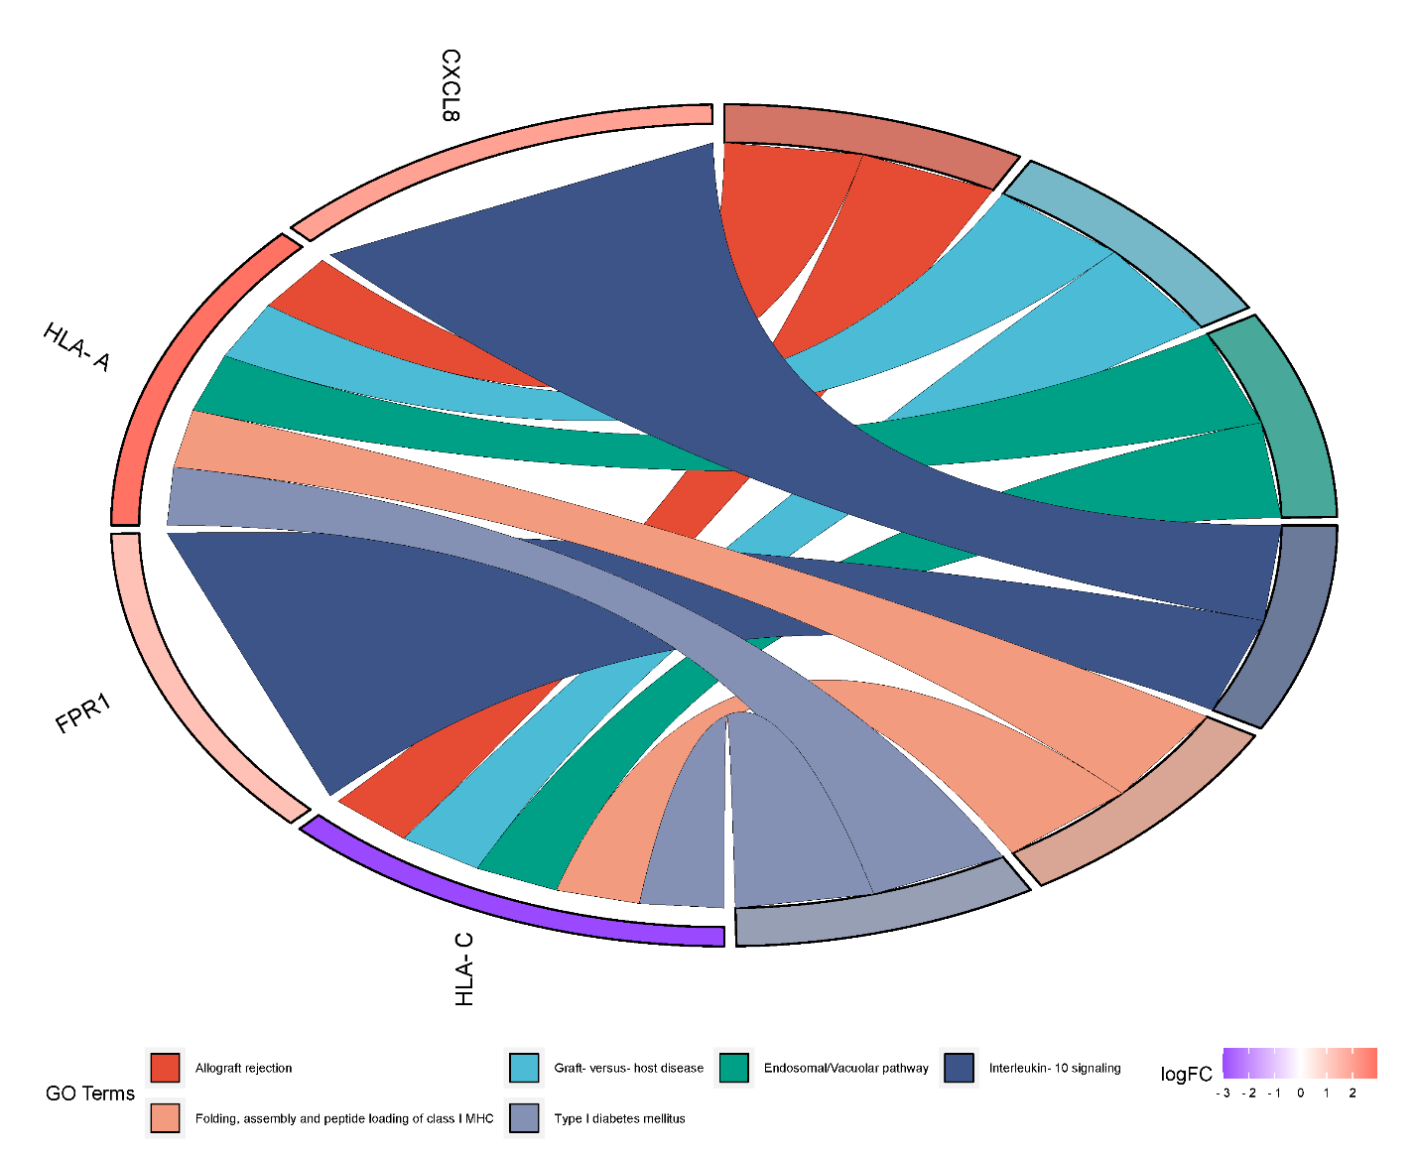

**Figure 12:Pathway Chord Diagram**

**3.5 The gene regulatory network analysis revealed networks of interactions between TF and genes and DEG-miRNA**.

In order to find the important miRNAs connected to the hub genes, an interaction network was built to investigate the connections between hub genes and miRNAs. By adding the official symbol to the gene list of human heart tissue using the TarBase database in NetworkAnalyst, we were able to determine which microRNAs (miRNAs) interacted with the Key genes, as shown in ***Figure 12*** .Nine important miRNAs were selected as hub gene post-transcriptional regulatory factors degree score >= 4 (hsa-mir-23b-3p, hsa-mir-129-2-3p, hsa-mir-23a-3p, hsa-mir-34a-5p, and hsa-mir-21-3p) determines the ranking. A robust link has been found between these miRNAs and drug resistance in AUD, according to the literature review. The KG and TF interaction networks were constructed similarly, using NetworkAnalyst's JASPAR database. Six TFs with betweenness >= 5 were selected as transcriptional regulatory factors of KGs, as shown in ***Figure 13***. These TFs include GREB1, SRF, FOXC1, GATA2, PRDM1, and YY1. TFs and significant miRNAs are included in Supplementary Table S8, along with their degree scores.

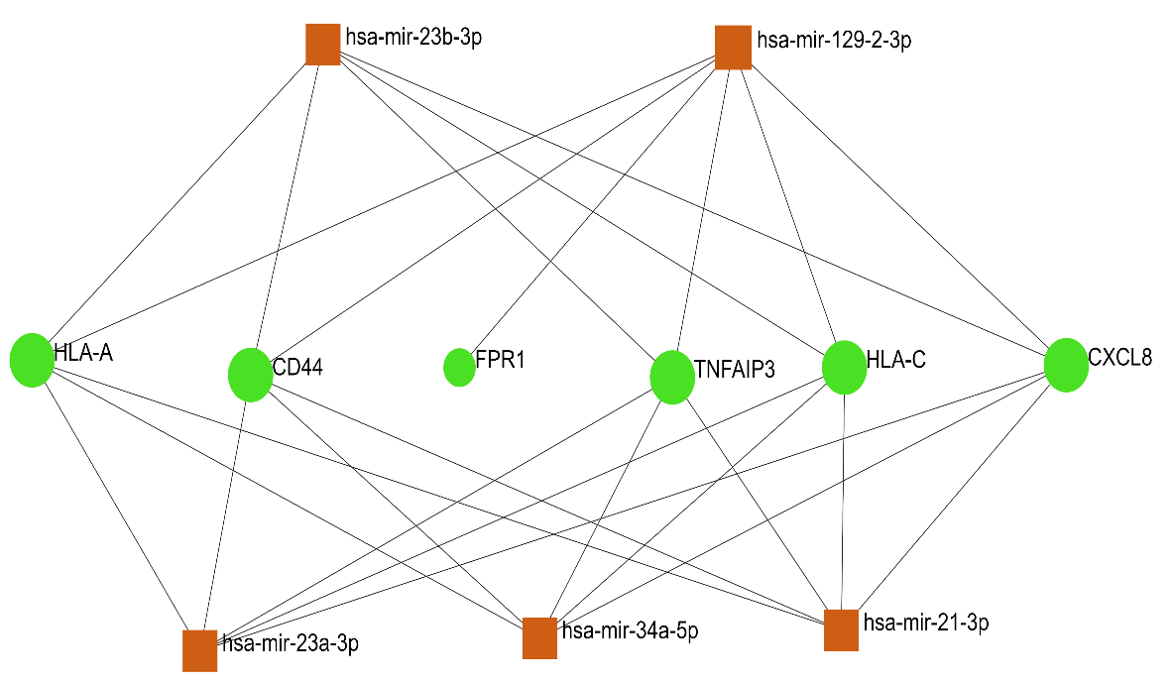

**Figure 13:miRNA with hub genes**

***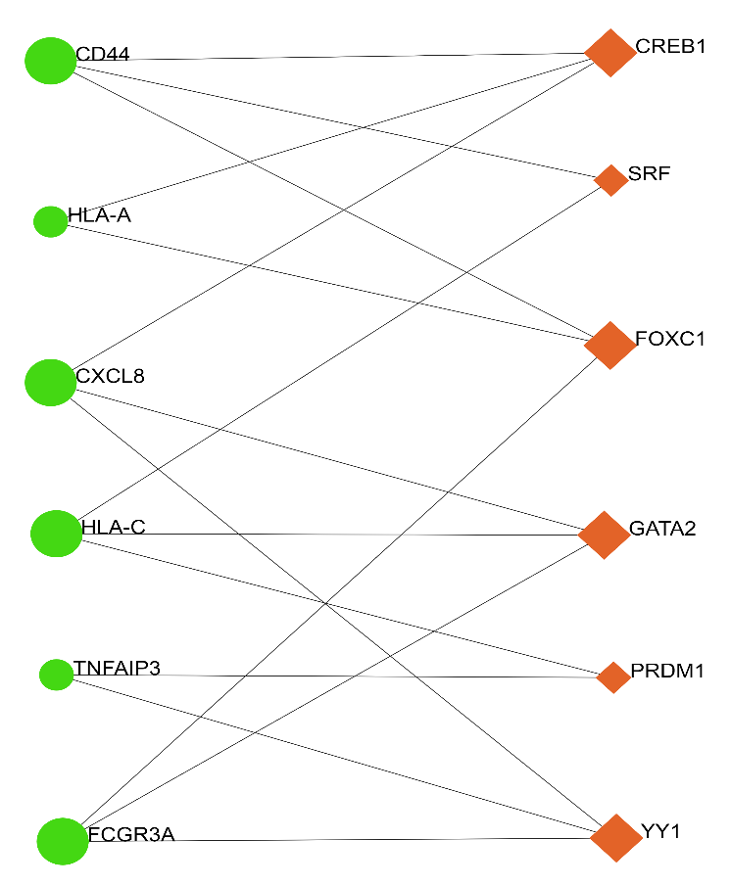*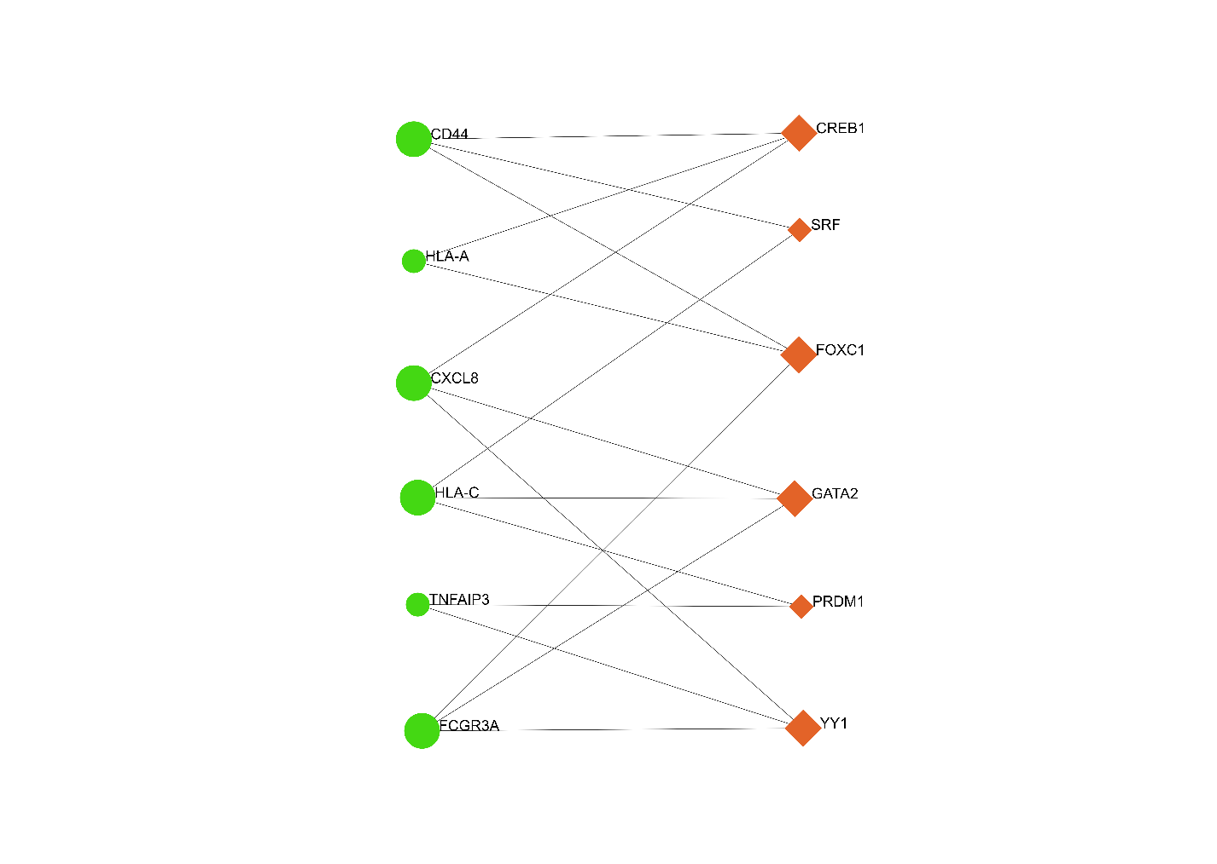**

**Figure 14:TF with hub genes**

Figure 12 miRNA and hub genes; the miRNAs are shown by the bright green color (rectangle shape) and Figure 13 the interaction between the AUD-related TF and hub genes is indicated by the rectangle shape.

**3.6 Hub Genes Validation**

We validated biomarkers using the ROC curve for the GEO profile dataset with access number GSE28619 for seven KGs (CXCL8, FCGR3A, HLA-C, HLA-A, CD44, FPR1 and TNFAIP3), the GEO profile dataset with access number GSE28619 for 22 Samples. Examination of livers affected by alcohol-related hepatitis (AH). AH is a severe kind of alcoholic liver disease that is characterized by pericellular fibrosis, steatosis, and hepatocellular destruction. The findings provide light on the molecular pathways underlying the development of AH. We found that the area under the ROC curve (AUC) for the hub genes ranged from 0.514 to 0.905 indicating good validation performance. The overall information of ROC analysis result is described in Table 3.

**Table 4:ROC analysis results.**

|  |  |  |  |
| --- | --- | --- | --- |
| Biomarker Type | **Biomarker Symbol** | **AUC** | **Dataset** |
| Hub Genes | CXCL8 | 0.895 | GSE28619 |
| FCGR3A | 0.514 |
| HLA-C | 0.724 |
| HLA-A | 0.905 |
| CD44 | 0.848 |
| FPR1 | 0.562 |
| TNFAIP3 | 0.600 |

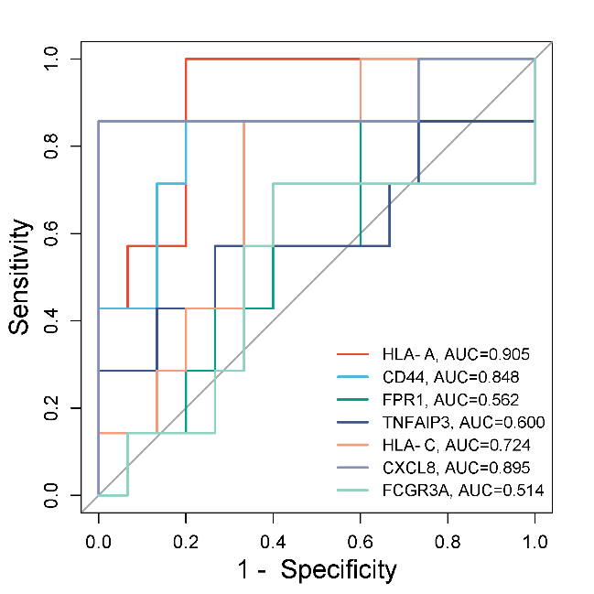

**Figure 15:Receiver Operating Characteristic (ROC) curve evaluating the diagnostic performance of the biomarkers in Alcohol Use Disorder (AUD).**

**4. Discussion**

Alcohol use disorder is a deadly illness that may claim a person's life. Because alcohol use disorder is so diverse, treatment may be quite challenging. Personalized therapy for alcohol use disorder will thus be helpful, although the prognosis for those who suffer from alcohol use disorder is not as good. Thus, the development of new biomarkers leveraging heterogeneity and Data from single-cell RNA sequencing (scRNA-seq) is a critical goal for increasing the individualized and accurate treatment of alcohol use disorder going forward. To examine single-cell RNA sequencing (scRNA-seq) information from individuals with alcohol use disorder's peripheral blood, we used bioinformatics techniques in this work. We set out to investigate the possibility of cellular heterogeneity, find genes that are differentially expressed (DEGs), study pertinent biological pathways, build a network of protein-protein interactions (PPIs), identify important genes, appraise transcription factors (TFs) and conduct microRNA analysis (miRNAs). Using the sophisticated capabilities of scRNA-seq, the PBMCs grouped in 28 cellular subgroups based on our RAW data set. In all five of the experimental groups in the subjects of our investigation were dendritic cells, T cells, monocytes, naive B cells, and natural killer cellswe saw similar cell proportions for each kind of cell. Microarray data are now widely employed in biological research and are a valuable tool for identifying potential biomarkers. Microarray gene expression profiling is a prominent technique used to find DEGs in many illnesses, such as alcohol use disorder. Variations in gene expression in peripheral blood monolayer cells (PBMC) of individuals with alcohol use disorder were analyzed, and significant changes in the 82 genes expression profiles in datasets matching to the dendritic cell cluster were discovered. Two datasets, GSE182173 and GSE182440, which shared differentially expressed genes with a cluster of dendritic cells, were used in our analysis. Notable Gene Ontology (GO) words have been identified in connection with molecular functions (MF), cellular components (CC), and biological processes (BP). To comprehensively characterize the functional activities performed by gene products in several species, the Gene Ontology (GO) provides a thorough framework and a variety of conceptual tools. This technique is meant to make it easier to depict biological processes on computers. Facilitating the computer representation of biological systems is the goal of the Gene Ontology (GO). In addition to giving information about the function of the gene, GO annotations explain the relationship between a gene product and a GO concept [53]. We discovered throughout our research that translation is one of the fundamental ideas in gene ontology that relates to biological functions. Initiating the translation of RNA molecules linked to certain biomolecules is the responsibility of translation [54]. An intense correlation was shown by the enrichment analysis of the abstracts between signal transduction, immunological response, cell surface receptor connected signal transduction, carbohydrate-mediated signaling, and alcohol use disorder (AUD) [55] [56][57]. According to research, AUD may be exacerbated by a particular protein deficit [58]. The present body of knowledge on cerebral cavernous malformation (CCM) research centers on the mechanisms underlying the development, targeting, and establishment of channels and their complexes in the postmortem putamen [59]. A number of different postmortem putamen have been linked to lysosome dysfunction [60]. Maintaining cardiac homeostasis and sending crucial signals to the postmortem putamen are critically dependent on the extracellular matrix network [61]. In order to reconstruct the postmortem putamen, exosomes are necessary [61]. Major Histocompatibility Antigen (MHC) class I molecules displaying viral antigens facilitate an immunological response in the setting of myocarditis [62]. Brain stroke pathophysiology may be significantly influenced by changes in the excitation-contraction electrical current coupling. While nonobstructive AUD causes increased serine-threonine kinase activity, calcium channel inhibitor activity, and adenylate cyclase binding, it also causes decreased intercellular communication in the postmortem putamen, which impacts different cellular activities. Pattern recognition receptors (PRRs) are a type of receptors that recognizes pathogen-associated molecular patterns (PAMPs) as well as damage-associated molecular patterns (DAMPs). PRRs are essential for both the detection of invasive infections and the innate immune response to microbial agents [63][64]. Aside from triggering acquired immunity and interferon-mediated antiviral responses, PRR activation also causes inflammatory reactions [65]. Nucleotide-binding oligomerization domain-like receptors (NLRs), Toll-like receptors (TLRs), RIG-I-like receptors (RLRs), and other receptors belong to the family of pattern recognition receptors (PRRs). and additional receptors [66]. Peptides, carbohydrates, lipoproteins, and nucleic acids are just a few of the ligands that these receptors can identify [67]. Type I interferons and inflammatory cytokines that are constitutively synthesized as a consequence of PRR growth aberrant identification of self-derived nucleic acids may aid when autoimmune or autoinflammatory diseases begin to manifest. It may be helpful to design therapeutic medicines for a variety of disorders to comprehend the activation and regulatory processes of PRRs, such as NLRs. As hub gene post-transcriptional regulatory factors with a substantial link to treatment resistance in AUD, the research identified nine miRNAs (hsa-mir-23b-3p, hsa-mir-129-2-3p, hsa-mir-23a-3p, hsa-mir-34a-5p, and hsa-mir-21-3p) [68]. Moreover, it has been shown that six transcriptional regulatory factors—GREB1, SRF, FOXC1, GATA2, PRDM1, and YY1—are essential for the transcriptional control of KGs [69]. The association between hub genes and miRNAs was investigated using the TarBase database, and the KG and TF interaction networks were created using the JASPAR database [70]. In order to diagnose and treat AUD, our results open up a possible path for the creation of new biomarkers [71]. In this work, single-cell RNA sequencing (scRNA-seq) data processing and peripheral blood mononuclear cells (PBMCs) were used to investigate alcohol use disorder (AUD). [72]. 82 genes within the dendritic cell cluster were found to be differently expressed in the research, underscoring the significance of cellular heterogeneity and possible biomarkers for AUD [73]. The study of Gene Ontology demonstrated the connection between AUD and important biological processes like as immune response, cell surface receptor signaling, and signal transmission [74]. An emphasis on how pattern recognition receptors work was placed on the complex networks of the postmortem putamen in this investigation [9]. Furthermore, it was shown that miRNAs and transcription factors are viable options for both therapeutic and diagnostic treatments in AUD [75]. As a whole, these results advance our knowledge of AUD and open the door to the development of new biomarkers that may improve customized interventions.

**5. Conclusion**

To effectively use disease-modifying therapies in the progression of alcohol use disorder, it will be important to identify potential biomarkers and related pathways. This research provided an overview of network-based techniques for identifying the metabolic pathways contributing to the development of alcohol consumption disorders. A thorough bioinformatics analysis was used to identify 82 DEGs from two transcriptome data sets related to alcohol use disorder. After that, a PPI network was constructed using these DEGs, and the hub genes that ranked highest on the PPI network were recognized as promising new biomarkers to identify the illness alcohol use disorder. Then, among the common genes linked to alcohol use disorder, many TFs, such as GREB1, SRF, FOXC1, GATA2, PRDM1, and YY1, and hsa-mir-23b-3p, hsa-mir-129-2-3p, hsa-mir-23a-3p, hsa-mir-34a-5p, and hsa-mir-21-3p are examples of miRNAs, were found. Further research is required to verify the anticipated drugs. All these indicators, in our opinion, will make it possible to identify alcohol use disorder in cardiac samples more quickly and affordably. This method of identifying biomarkers may be used to assess the existence and activity of biomarkers in difficult-to-reach tissue using easily accessible brain tissue, in addition to being used to various therapeutic problems. As a result, we suggest a more thorough validation of both this paradigm and the putative biomarker transcripts that our clinical study has discovered. The effectiveness of the biomarkers as diagnostics was shown by the ROC analysis. By identifying alcholic samples, each of these biomarkers, in our opinion, will enable the faster and more affordable identification of alcohol use problem. As such, we suggest a more thorough confirmation of both this paradigm and the possible biomarker transcripts found by our clinical investigation.

**6. References**

[1] M. S. Smirnov, T. R. Garrett, and R. Yasuda, “An open-source tool for analysis and automatic identification of dendritic spines using machine learning,” *PLoS One*, vol. 13, no. 7, p. e0199589, Jul. 2018, doi: 10.1371/journal.pone.0199589.

[2] Y. Yu *et al.*, “Improved prediction of bacterial CRISPRi guide efficiency from depletion screens through mixed-effect machine learning and data integration,” *Genome Biol*, vol. 25, no. 1, p. 13, Jan. 2024, doi: 10.1186/s13059-023-03153-y.

[3] B. Tang, Z. Pan, K. Yin, and A. Khateeb, “Recent Advances of Deep Learning in Bioinformatics and Computational Biology,” *Front Genet*, vol. 10, Mar. 2019, doi: 10.3389/fgene.2019.00214.

[4] Crews FT, Vetreno RP, Broadwater MA, and Robinson DL, “Biomarkers for alcohol use disorder.”.

[5] Crews FT, Zou J, and Qin L, “Induction of innate immune genes in brain create the neurobiology of addiction”.

[6] Szabo G and Saha B, “Alcohol’s effect on host defense”.

[7] T. Xiao, Y. Chen, A. Boisvert, M. Cole, and A. Kimbrough, “Chronic Intermittent Ethanol Vapor Exposure Paired with Two-Bottle Choice to Model Alcohol Use Disorder,” *Journal of Visualized Experiments*, no. 196, Jun. 2023, doi: 10.3791/65320.

[8] Patrick J. Mulholland, Stefano Berto, and Phillip A. Wilmarth, “Adaptor protein complex 2 in the orbitofrontal cortex predicts alcohol use disorder”.

[9] J. Wang, Y. Liu, Q. Xia, J. Liang, J. Wang, and J. Li, “Functional roles, regulatory mechanisms and theranostics applications of ncRNAs in alcohol use disorder,” *Int J Biol Sci*, vol. 19, no. 4, pp. 1316–1335, 2023, doi: 10.7150/ijbs.81518.

[10] A. S. Miele *et al.*, “Driven by need, shaped by access: Heterogeneity in patient profiles and patterns of service utilization in patients with alcohol use disorders,” *Drug Alcohol Depend*, vol. 246, p. 109825, May 2023, doi: 10.1016/j.drugalcdep.2023.109825.

[11] G. M. Belay, K. K. W. Lam, Q. Liu, C. S. T. Wu, Y. W. Mak, and K. Y. Ho, “Magnitude and determinants of alcohol use disorder among adult population in East Asian countries: A systematic review and meta-analysis,” *Front Public Health*, vol. 11, Feb. 2023, doi: 10.3389/fpubh.2023.1144012.

[12] R. Mojtabai, “Estimating the Prevalence of Substance Use Disorders in the US Using the Benchmark Multiplier Method,” *JAMA Psychiatry*, vol. 79, no. 11, p. 1074, Nov. 2022, doi: 10.1001/jamapsychiatry.2022.2756.

[13] E. T. Honoré, S. H. Jakobsen, M. Osler, and T. S. H. Jørgensen, “The impact of AUD on death for men with different IQ-scores: a register-based cohort study of 645 955 men,” *Alcohol and Alcoholism*, vol. 58, no. 4, pp. 442–450, Jul. 2023, doi: 10.1093/alcalc/agad020.

[14] G. Askgaard *et al.*, “Influence of vaccination on adverse health outcomes after SARS‐CoV‐2 infection among individuals with alcohol use disorder: a population‐based study,” *Addiction*, vol. 118, no. 8, pp. 1482–1492, Aug. 2023, doi: 10.1111/add.16196.

[15] G. Enos, “AUD drugs’ liver‐related benefits highlight need for greater access,” *Alcoholism & Drug Abuse Weekly*, vol. 34, no. 21, pp. 1–8, May 2022, doi: 10.1002/adaw.33444.

[16] A. Siomek-Gorecka, A. Dlugosz, and D. Czarnecki, “The Molecular Basis of Alcohol Use Disorder (AUD). Genetics, Epigenetics, and Nutrition in AUD: An Amazing Triangle,” *Int J Mol Sci*, vol. 22, no. 8, p. 4262, Apr. 2021, doi: 10.3390/ijms22084262.

[17] H. Cheng, W. Chen, Y. Lin, J. Zhang, X. Song, and D. Zhang, “Signaling pathways involved in the biological functions of dendritic cells and their implications for disease treatment,” *Molecular Biomedicine*, vol. 4, no. 1, p. 15, May 2023, doi: 10.1186/s43556-023-00125-3.

[18] X. Wang *et al.*, “The role of dendritic cells in COVID-19 infection,” *Emerg Microbes Infect*, vol. 12, no. 1, Dec. 2023, doi: 10.1080/22221751.2023.2195019.

[19] E. Marmonti, J. Oliva-Ramirez, and C. Haymaker, “Dendritic Cells: The Long and Evolving Road towards Successful Targetability in Cancer,” *Cells*, vol. 11, no. 19, p. 3028, Sep. 2022, doi: 10.3390/cells11193028.

[20] G. Izumi, K. Koga, and Y. Osuga, “Dendritic cells,” in *Immunology of Endometriosis*, Elsevier, 2022, pp. 43–49. doi: 10.1016/B978-0-12-820661-4.00014-5.

[21] Yasuo Nagafuchi, Umarov Alisher Sheralievich, and Norbekov Sarvar Sunatullayevich, “Immunomics analysis of rheumatoid arthritis identified precursor dendritic cells as a key cell subset of treatment resistance”.

[22] E. Sosa Cuevas, P. Saas, and C. Aspord, “Dendritic Cell Subsets in Melanoma: Pathophysiology, Clinical Prognosis and Therapeutic Exploitation,” *Cancers (Basel)*, vol. 15, no. 8, p. 2206, Apr. 2023, doi: 10.3390/cancers15082206.

[23] A. Butler, P. Hoffman, P. Smibert, E. Papalexi, and R. Satija, “Integrating single-cell transcriptomic data across different conditions, technologies, and species,” *Nat Biotechnol*, vol. 36, no. 5, pp. 411–420, Jun. 2018, doi: 10.1038/nbt.4096.

[24] Xinyi Lin, Joshua Ho, and Gordon Qian, “Fundamentals of scRNA-Seq Analysis.” Accessed: Apr. 14, 2023. [Online]. Available: https://holab-hku.github.io/Fundamental-scRNA/

[25] A. S. Arefin, C. Riveros, R. Berretta, and P. Moscato, “kNN-MST-Agglomerative: A fast and scalable graph-based data clustering approach on GPU,” in *2012 7th International Conference on Computer Science & Education (ICCSE)*, 2012, pp. 585–590. doi: 10.1109/ICCSE.2012.6295143.

[26] N. Al Mahi, M. F. Najafabadi, M. Pilarczyk, M. Kouril, and M. Medvedovic, “GREIN: An Interactive Web Platform for Re-analyzing GEO RNA-seq Data,” *Sci Rep*, vol. 9, no. 1, Dec. 2019, doi: 10.1038/s41598-019-43935-8.

[27] X. Liu, Q. Liu, L. Liang, G. Chen, L. Meng, and P. Zeng, “The mechanism of Astragalus membranaceus in treating peritoneal fibrosis by intervening the key syndrome and pathology based on Q-marker theory,” *Precision Medicine Research*, vol. 4, no. 2, p. 10, 2022, doi: 10.53388/pmr20220010.

[28] L. S. Nguyen *et al.*, “Transcriptome profiling of UPF3B/NMD-deficient lymphoblastoid cells from patients with various forms of intellectual disability,” *Mol Psychiatry*, vol. 17, no. 11, pp. 1103–1115, Nov. 2012, doi: 10.1038/mp.2011.163.

[29] S. Yang *et al.*, “Mutant BCL11B in a Patient With a Neurodevelopmental Disorder and T-Cell Abnormalities,” *Front Pediatr*, vol. 8, Oct. 2020, doi: 10.3389/fped.2020.544894.

[30] M. Pathan *et al.*, “FunRich: An open access standalone functional enrichment and interaction network analysis tool,” *Proteomics*, vol. 15, no. 15, pp. 2597–2601, Aug. 2015, doi: 10.1002/pmic.201400515.

[31] D. W. Huang *et al.*, “The DAVID Gene Functional Classification Tool: A novel biological module-centric algorithm to functionally analyze large gene lists,” *Genome Biol*, vol. 8, no. 9, Sep. 2007, doi: 10.1186/gb-2007-8-9-r183.

[32] J. A. Abedini, S. Handa, S. Edwards, B. Chorley, and H. El-Masri, “Identification of differentially expressed genes and networks related to hepatic lipid dysfunction,” *Toxicol Appl Pharmacol*, vol. 382, Nov. 2019, doi: 10.1016/j.taap.2019.114757.

[33] C. von Mering, M. Huynen, D. Jaeggi, S. Schmidt, P. Bork, and B. Snel, “STRING: A database of predicted functional associations between proteins,” Jan. 01, 2003. doi: 10.1093/nar/gkg034.

[34] M. Kohl, S. Wiese, and B. Warscheid, “Cytoscape: Software for Visualization and Analysis of Biological Networks,” in *Methods in Molecular Biology*, vol. 696, Humana Press Inc., 2011, pp. 291–303. doi: 10.1007/978-1-60761-987-1_18.

[35] C. H. Chin, S. H. Chen, H. H. Wu, C. W. Ho, M. T. Ko, and C. Y. Lin, “cytoHubba: Identifying hub objects and sub-networks from complex interactome,” *BMC Syst Biol*, vol. 8, no. 4, Dec. 2014, doi: 10.1186/1752-0509-8-S4-S11.

[36] A. V. G. Camilo Gomez and J. N. Soulakova, “Constructing UpSet plot for survey data with weights using SAS and R software,” *Commun Stat Simul Comput*, vol. 52, no. 6, pp. 2320–2326, 2023, doi: 10.1080/03610918.2021.1904142.

[37] W. Walter, F. Sánchez-Cabo, and M. Ricote, “GOplot: An R package for visually combining expression data with functional analysis,” *Bioinformatics*, vol. 31, no. 17, pp. 2912–2914, Feb. 2015, doi: 10.1093/bioinformatics/btv300.

[38] T. Rajalahti, R. Arneberg, A. C. Kroksveen, M. Berle, K. M. Myhr, and O. M. Kvalheim, “Discriminating variable test and selectivity ratio plot: Quantitative tools for interpretation and variable (biomarker) selection in complex spectral or chromatographic profiles,” *Anal Chem*, vol. 81, no. 7, pp. 2581–2590, Apr. 2009, doi: 10.1021/ac802514y.

[39] X. Zhang *et al.*, “Identification of key pseudogenes in nasopharyngeal carcinoma based on RNA-Seq analysis,” *BMC Cancer*, vol. 21, no. 1, Dec. 2021, doi: 10.1186/s12885-021-08211-x.

[40] G. Zhou, O. Soufan, J. Ewald, R. E. W. Hancock, N. Basu, and J. Xia, “NetworkAnalyst 3.0: A visual analytics platform for comprehensive gene expression profiling and meta-analysis,” *Nucleic Acids Res*, vol. 47, no. W1, pp. W234–W241, Jul. 2019, doi: 10.1093/nar/gkz240.

[41] O. Fornes *et al.*, “JASPAR 2020: Update of the open-Access database of transcription factor binding profiles,” *Nucleic Acids Res*, vol. 48, no. D1, pp. D87–D92, Jan. 2020, doi: 10.1093/nar/gkz1001.

[42] S. Da Hsu *et al.*, “MiRTarBase: A database curates experimentally validated microRNA-target interactions,” *Nucleic Acids Res*, vol. 39, no. SUPPL. 1, Jan. 2011, doi: 10.1093/nar/gkq1107.

[43] C. J. Grondin *et al.*, “Advancing exposure science through chemical data curation and integration in the comparative toxicogenomics database,” *Environ Health Perspect*, vol. 124, no. 10, pp. 1592–1599, Oct. 2016, doi: 10.1289/EHP174.

[44] T. Ilicic *et al.*, “Classification of low quality cells from single-cell RNA-seq data,” *Genome Biol*, vol. 17, no. 1, Feb. 2016, doi: 10.1186/s13059-016-0888-1.

[45] G. Monaco *et al.*, “RNA-Seq Signatures Normalized by mRNA Abundance Allow Absolute Deconvolution of Human Immune Cell Types,” *Cell Rep*, vol. 26, no. 6, pp. 1627-1640.e7, Feb. 2019, doi: 10.1016/j.celrep.2019.01.041.

[46] “CXCL8 C-X-C motif chemokine ligand 8 [Homo sapiens (human)] - Gene - NCBI. (n.d.).” Accessed: Sep. 21, 2024. [Online]. Available: https://www.ncbi.nlm.nih.gov/gene/3576

[47] “FCGR3A Fc gamma receptor IIIa [Homo sapiens (human)] - Gene - NCBI.” Accessed: Sep. 21, 2024. [Online]. Available: https://www.ncbi.nlm.nih.gov/gene/2214

[48] “HLA-A major histocompatibility complex, class I, A [Homo sapiens (human)] - Gene - NCBI.” Accessed: Sep. 21, 2024. [Online]. Available: https://www.ncbi.nlm.nih.gov/gene/3105

[49] “CD44 CD44 molecule (IN blood group) [Homo sapiens (human)] - Gene - NCBI.” Accessed: Sep. 21, 2024. [Online]. Available: https://www.ncbi.nlm.nih.gov/gene/960

[50] “FPR1 formyl peptide receptor 1 [Homo sapiens (human)] - Gene - NCBI.” Accessed: Sep. 21, 2024. [Online]. Available: https://www.ncbi.nlm.nih.gov/gene/2357

[51] “TNFAIP3 TNF alpha induced protein 3 [Homo sapiens (human)] - Gene - NCBI.” Accessed: Sep. 21, 2024. [Online]. Available: https://www.ncbi.nlm.nih.gov/gene/7128

[52] “HLA-C major histocompatibility complex, class I, C [Homo sapiens (human)] - Gene - NCBI.” Accessed: Sep. 21, 2024. [Online]. Available: https://www.ncbi.nlm.nih.gov/gene/3107

[53] P. D. Thomas, “The Gene Ontology and the Meaning of Biological Function,” 2017, pp. 15–24. doi: 10.1007/978-1-4939-3743-1_2.

[54] M. Liu and P. D. Thomas, “GO functional similarity clustering depends on similarity measure, clustering method, and annotation completeness,” *BMC Bioinformatics*, vol. 20, no. 1, p. 155, Dec. 2019, doi: 10.1186/s12859-019-2752-2.

[55] D. Tang *et al.*, “Arylsulphatase A Pseudodeficiency (ARSA-PD), hypertension and chronic renal disease in Aboriginal Australians,” *Sci Rep*, vol. 8, no. 1, p. 10912, Jul. 2018, doi: 10.1038/s41598-018-29279-9.

[56] S. K. Kim, J. S. Hwang, H. Y. Kang, and H. Y. Kang, “Acrodermatitis enteropathica‐like dermatosis associated with combined deficiency of zinc and amino acids,” *Int J Dermatol*, vol. 48, no. 8, pp. 909–910, Aug. 2009, doi: 10.1111/j.1365-4632.2009.04165.x.

[57] B. Peters *et al.*, “Protein-losing enteropathy in camptodactyly-arthropathy-coxa vara-pericarditis (CACP) syndrome,” *Pediatric Rheumatology*, vol. 14, no. 1, p. 32, Dec. 2016, doi: 10.1186/s12969-016-0093-5.

[58] A. E. Moore, D. M. Chenette, L. C. Larkin, and R. J. Schneider, “Physiological networks and disease functions of <scp>RNA</scp> ‐binding protein <scp>AUF1</scp>,” *WIREs RNA*, vol. 5, no. 4, pp. 549–564, Jul. 2014, doi: 10.1002/wrna.1230.

[59] Jacob Croft, Brian Grajeda, Luis A. Aguirre, and Liyuan Gao, “Whole-genome Omics delineates the function of CCM1 within the CmPn networks”.

[60] M. Matta *et al.*, “Cardiac Contractility Modulation (CCM) Italian Registry: preliminary analysis,” *EP Europace*, vol. 24, no. Supplement_1, May 2022, doi: 10.1093/europace/euac053.517.

[61] D. R. Vannier *et al.*, “CCM2-deficient endothelial cells undergo a ROCK-dependent reprogramming into senescence-associated secretory phenotype,” *Angiogenesis*, vol. 24, no. 4, pp. 843–860, Nov. 2021, doi: 10.1007/s10456-021-09809-2.

[62] J. Abou-Fadel, M. Smith, K. Falahati, and J. Zhang, “Comparative omics of CCM signaling complex (CSC),” *Chin Neurosurg J*, vol. 6, no. 1, p. 4, Dec. 2020, doi: 10.1186/s41016-019-0183-6.

[63] Ziske Maritska and R. Hidayat, “The Role of Pattern Recognition Receptor (PRR) in the Body’s Defense System: A Narrative Literature Review,” *Open Access Indonesian Journal of Medical Reviews*, vol. 3, no. 2, pp. 394–397, May 2023, doi: 10.37275/oaijmr.v3i2.300.

[64] C. Bryant and T. P. Monie, “Pattern recognition receptors in GtoPdb v.2023.1,” *IUPHAR/BPS Guide to Pharmacology CITE*, vol. 2023, no. 1, Apr. 2023, doi: 10.2218/gtopdb/F302/2023.1.

[65] U. Ohto, “Activation and regulation mechanisms of NOD-like receptors based on structural biology,” *Front Immunol*, vol. 13, Sep. 2022, doi: 10.3389/fimmu.2022.953530.

[66] N. Kano, G. H. Ong, D. Ori, and T. Kawai, “Pathophysiological Role of Nucleic Acid-Sensing Pattern Recognition Receptors in Inflammatory Diseases,” *Front Cell Infect Microbiol*, vol. 12, Jun. 2022, doi: 10.3389/fcimb.2022.910654.

[67] E. A. Oliveira *et al.*, “In silico selection of damage-associated molecular patterns (DAMPS) and their receptors in humans,” *Research, Society and Development*, vol. 11, no. 10, p. e452111032838, Aug. 2022, doi: 10.33448/rsd-v11i10.32838.

[68] M. Li, Q. He, and L. Chen, “Identifying Hub Genes and miRNA-mRNA Regulatory Networks in Mice Infected with H1N1 Influenza Virus,” *Dis Markers*, vol. 2023, pp. 1–18, May 2023, doi: 10.1155/2023/2291051.

[69] Y.-M. Yan *et al.*, “Hub genes, diagnostic model, and predicted drugs in systemic sclerosis by integrated bioinformatics analysis,” *Front Genet*, vol. 14, Jul. 2023, doi: 10.3389/fgene.2023.1202561.

[70] Y. Zhang and H. Kiryu, “Identification of oxidative stress-related genes differentially expressed in Alzheimer’s disease and construction of a hub gene-based diagnostic model,” *Sci Rep*, vol. 13, no. 1, p. 6817, Apr. 2023, doi: 10.1038/s41598-023-34021-1.

[71] R. Liu *et al.*, “The hub genes and their potential regulatory mechanisms in chronic spontaneous urticaria revealed by integrated transcriptional expression analysis,” *Exp Dermatol*, vol. 32, no. 6, pp. 840–851, Jun. 2023, doi: 10.1111/exd.14785.

[72] R. Li *et al.*, “RNA alternative splicing impacts the risk for alcohol use disorder,” *Mol Psychiatry*, vol. 28, no. 7, pp. 2922–2933, Jul. 2023, doi: 10.1038/s41380-023-02111-1.

[73] S. B. Huggett, A. S. Ikeda, Q. Yuan, C. E. Benca-Bachman, and R. H. C. Palmer, “Genome- and transcriptome-wide splicing associations with alcohol use disorder,” *Sci Rep*, vol. 13, no. 1, p. 3950, Mar. 2023, doi: 10.1038/s41598-023-30926-z.

[74] Sloan A., Lewis, and Brianna Doratt, “Integrated single cell analysis shows chronic alcohol drinking disrupts monocyte differentiation in the bone marrow niche”.

[75] K. Holloway *et al.*, “Cerebellar Transcriptomic Analysis in a Chronic plus Binge Mouse Model of Alcohol Use Disorder Demonstrates Ethanol-Induced Neuroinflammation and Altered Glial Gene Expression,” *Cells*, vol. 12, no. 5, p. 745, Feb. 2023, doi: 10.3390/cells12050745.